BRAILLE-BRIDGE
How BrailleBridge Compares
A first-person comparison of BrailleBridge 1 with the main Braille writing devices, checked against the makers' and sellers' own pages.
Document | Comparison paper, version 1.0, November 2026
Author | Samin Yeasar
Email | samin@mentormind.bd
GitHub | github.com/Solez-ai/braille.bridge
Official website | braile-bridge.vercel.app
Sources checked | Maker and seller product pages, accessed 4 November 2026; numbered references at the end
Project status | BrailleBridge 1 is a working prototype that I am still developing

1. Summary
I built BrailleBridge 1 because a blind student who writes in Braille still depends on someone else to turn that writing into something a sighted teacher can read. In Bangladesh that someone is usually a scribe [17]. In this paper I compare my device with the main kinds of Braille writing device on sale today, and I explain where I think mine is better and where it is not.
BrailleBridge 1 is a six-key chord keyboard, plus Space and Shift, with an ESP32 inside. Each chord goes over Bluetooth to a browser-based Teacher Software that shows the teacher ordinary text, in English or Bangla. The prototype costs me about US$12 in parts [19].
What I found
Cost. The devices I checked sell for US$149 to US$2,995 on the pages I cite. My prototype costs about US$12 in parts, which is 12 to 250 times less. That is a parts cost against a selling price, and section 4 explains why I still think the comparison is fair.
Classroom. The one device that lets a teacher follow along without knowing Braille, the Perkins SMART Brailler, does it for one student at a time [2]. In the pages I read, I could not find any product that shows several students' Braille as live text on one teacher screen. BrailleBridge is built to do that.
Independence. My device needs no phone and no screen reader on the student's side. The Bluetooth keyboards I checked need a phone, tablet or computer [5][6].
Repair and ownership. BrailleBridge uses common parts and an open licence (Apache 2.0) [19]. I found nothing about open designs for the commercial devices.

2. How BrailleBridge works, in one minute
My device has two halves that talk over Bluetooth. The student side is a hand-sized keyboard. The teacher side is a web page.
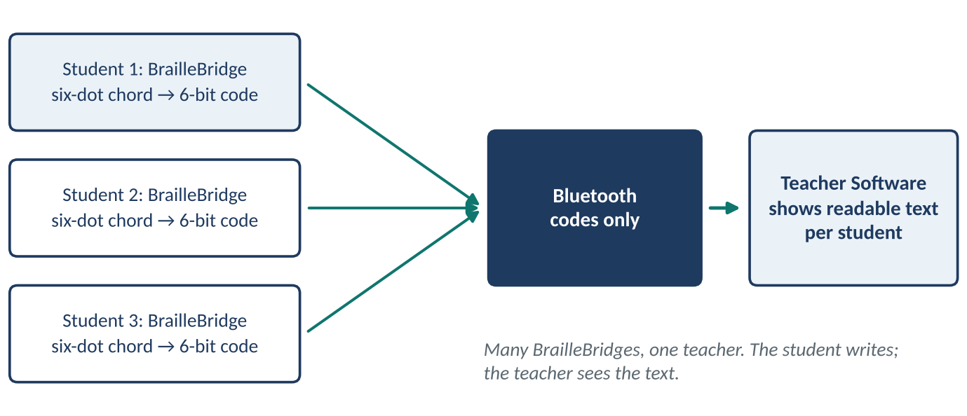
Figure 1. Many BrailleBridges, one teacher: the student writes, the teacher sees text.
- Press. The student presses the dots of a letter together, as one chord, on six mechanical keys. Space and Shift are separate keys.
- Translate. The ESP32 waits 180 ms, collects the keys pressed in that window as one chord, and turns it into a code.
- Send. Only the chord codes travel over Bluetooth, so the link stays light.
- Read. The Teacher Software runs in an ordinary browser, decodes the codes into English or Bangla text, and shows live text for each student.
There are 63 chords, and with the Shift layers the device produces 252 outputs across four layers, which covers letters, numbers and punctuation in both languages [19].

3. How I did this comparison
I started from a list of the kinds of Braille writing and reading device on the market. For each kind I then opened the maker's or a seller's product page and checked the price, what the device needs in order to work, and what languages it supports. The pages are numbered in the references. I judged each device on seven questions:
- Cost. Could a school, a family or an NGO realistically buy one? I used US$200 as the line.
- Six-key Braille. Does the student type with Braille dot keys?
- Teacher reads text. Can a sighted teacher who does not know Braille read what was written?
- Many students. Can one teacher follow several students at once?
- Supports a second language. Can the device work in a language other than English? Whether that includes Bangla is discussed separately below.
- No phone needed. Does the student need no phone or computer of their own?
- Open or repairable. Can it be repaired or reproduced locally?

Scorecard
Device family | Under $200 | Six-key Braille | Teacher reads text | Many students | Supports a 2nd language | No phone needed | Open / repairable
Perkins Classic Brailler [3][4] | No | Yes | No | None found | Yes (any 6-dot code) | Yes | Partly
Perkins SMART Brailler [1][2] | No | Yes | Yes | None found | Yes (13) | Yes | Not found
Bluetooth keyboards [5][6][7] | Partly | Yes | Partly | None found | Yes | No | Not found
Braille-labeled QWERTY [8][9] | No | No | Yes | None found | Per model | No | Not found
Notetaker [10][11] | No | Yes | Partly | None found | Yes (EN, FR found) | Yes | Not found
Display + keyboard [11][12][13] | No | Yes | No | None found | Yes (Orbit); Not found (Mantis) | Partly | Not found
Touchscreen Braille [14] | Yes | Partly | Partly | None found | Not found | No | Not found
Embosser [15][16] | No | No | No | None found | Not found | No | Not found
BrailleBridge 1 [19] | Yes | Yes | Yes | Yes | Yes (EN, Bangla) | Yes | Yes
This scorecard is my own reading of the cited pages. "Not found" means I could not find the answer in any page I read; it does not mean the answer is no. "Partly" means the page supports some but not all of the question. The "Under $200" cell is "Partly" for Bluetooth keyboards because the Orbit Writer is $149 [5] while the Hable One is listed at EUR 239 [6].

4. Cost: the first and biggest gap
For many families in Bangladesh, assistive technology is a question of whether it can be bought at all. A study quoted by The Business Standard found that 75.36% of visually impaired students are held back by the high cost of assistive technology, and 92.96% lack access to accessible study materials [17]. Figure 2 sets the prices I found against my parts cost.
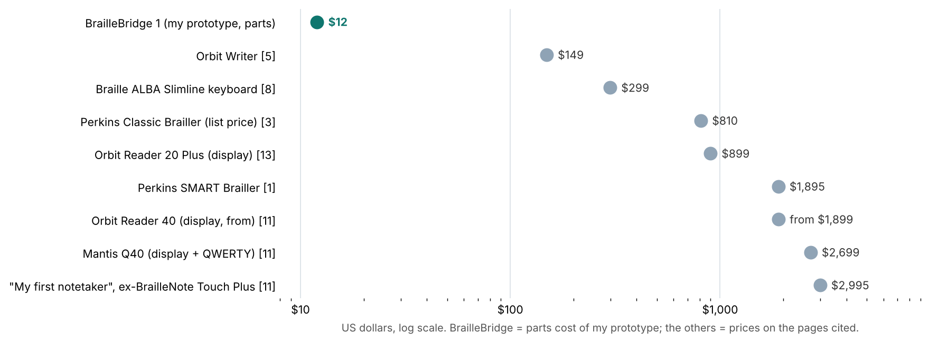
Figure 2. Prices on the pages I cite, against the BrailleBridge 1 prototype parts cost (log scale).
A fair note on this chart
My US$12 is the parts cost of a prototype, not a selling price. A finished product would add assembly, a case, testing, packaging, support and margin. Even at ten times the parts cost, about US$120, it would still sit below every device on the chart. Prices that I found in euros and pounds, such as the Hable One at EUR 239 [6] and the BraillePen Slim at EUR 307.50 [7], are in the text and not on the chart.
The same point holds for a class. Ten Perkins Classic Braillers cost US$8,100 at list price [3]. Ten Orbit Writers cost US$1,490 [5]. Ten BrailleBridges cost about US$120 in parts. That is the difference between a school that can equip a whole class and a school that can equip nobody.

5. Mechanical and electronic Braillers

5.1 Perkins Classic Brailler
What it is. A mechanical Braille writer with six keys, a space bar and a line-return lever. It embosses 25 lines of 42 cells on paper up to 11 by 11.5 inches [3]. RNIB describes it as a durable, closed-body machine used for over 70 years, and gives its weight as 4.8 kg [4]. The list price is US$810, which MaxiAids discounts to US$779 [3]; RNIB sells it for GBP 960 including VAT [4].
Where I think it falls short.
- The output is paper Braille. A sighted teacher who cannot read Braille cannot mark it. The seller pages I read describe only embossed output [3][4].
- It cannot save or send anything. I found no digital output on either page.
- It is heavy and expensive. At 4.8 kg [4] and US$779 to US$810 [3], it is a lot for a student to carry and for a family to buy.
How I think BrailleBridge does better. It weighs a fraction as much and costs about one-seventieth to build. Every chord becomes digital text as it is typed, so the teacher reads it on a screen immediately, and the work can be saved and shared. The student keeps the same six-key Braille skill; only the output changes. One thing I did not find on either seller page is a list of supported languages. Because the machine only embosses dots, I expect it can type any six-dot code, but I could not confirm that from a source.

5.2 Perkins SMART Brailler
What it is. An electronic Brailler for "displaying, vocalizing, and brailling what a student types"; Perkins sells it for US$1,895, reduced by US$300 from its earlier price [1]. Its screen shows Roman letters that mirror the student's Braille, so a teacher who does not know Braille can follow along [2]. It offers 13 language platforms, including Unified English Braille, Spanish, French, German, Russian, Swedish, Polish, Turkish, Arabic and Portuguese [1][2]. I did not find Bengali on either list.
Where I think it falls short. This is the closest rival to what I am building, because it also shows a sighted teacher what the student wrote. But it does that for one student per machine, on that machine's own screen. At US$1,895 it is about 158 times my parts cost, so a school can afford one at best and students must take turns. The Perkins page says it is bought through the American Printing House with Federal Quota funds [2], which suggests it is aimed at the US system; I did not find a Bangladesh price or distributor.
How I think BrailleBridge does better. It gives the same useful idea, a sighted teacher who can follow along without Braille, at a price that allows one per student. Several BrailleBridges connect to one Teacher Software session, so a teacher can follow a whole class, not one learner at one machine.

6. Bluetooth keyboards and QWERTY keyboards

6.1 Portable Bluetooth Braille keyboards (Orbit Writer, Hable One, BraillePen Slim)
What they are. Small Braille keyboards that connect to a phone, tablet or computer and type or control it. The Orbit Writer costs US$149, connects by Bluetooth or USB, works with iOS, Android, Windows, Mac and others, and supports "all languages available on phones and computers" [5]. The Hable One is listed at EUR 239, uses Bluetooth Low Energy, and states that it "does not work for computers" [6]; it supports more than 10 languages, including Spanish, French, German, Japanese, Arabic and Portuguese [6]. The BraillePen Slim is EUR 307.50 on the page I found, works over Bluetooth with PC, Mac, iOS and Symbian, and runs about 10 hours on its battery [7]. These are the closest rivals to BrailleBridge, so I want to be careful.
Where I think they fall short.
- They need a separate device. The Hable One describes itself as "only for typing and navigating on your phone" [6], and the Orbit Writer is described as a companion to a smartphone [5]. Without a phone or computer they do nothing.
- They control the student's own device, they are not built to deliver the student's writing to a teacher. In the pages I read I found no teacher view and no class view.
- Bangla depends on someone else's software. The Orbit Writer page says it supports all languages on the host device [5], which puts Bangla support in the phone's screen reader, not the keyboard. I could not find a source saying whether common screen readers handle Bangla Braille, and Bengali does not appear in Hable's list [6].
- I found nothing about open designs or local repair. None of the three pages mentions either.
How I think BrailleBridge does better. My device exists to carry the student's writing to the teacher. The student types, and the Teacher Software shows the text in a browser with nothing to install. Many BrailleBridges can join one session. English and Bangla are handled by my firmware and software together. The Orbit Writer is cheaper than the Hable One, but both still cost much more than my parts, and neither is open or built from parts a local workshop can swap.

6.2 Braille-labeled QWERTY keyboards (Braille ALBA, Nero Slimline)
What they are. Ordinary computer keyboards with raised Braille dots on the keys. One example, the Logickeyboard Braille ALBA Slimline, is a wired USB keyboard with molded Braille dots, 108 keys, and costs US$299 [8]. A Rehabmart guide describes the PC Nero Slimline as plug-and-play with no software needed [9]. Neither page describes a six-key Braille chord input, so I treat these as QWERTY keyboards with Braille markings; I could not confirm from the pages whether they accept Braille chords.
Where I think they fall short. If they do not take dot input, a student who writes only in Braille would have to learn a different way of typing, which defeats the purpose of Braille literacy. Their layout also varies by model; the ALBA page I read was for a Mac American English layout [8].
How I think BrailleBridge does better. It is a true Braille input device. The student presses dot combinations, the way Braille is meant to be written, and there is no QWERTY layout to learn first.

7. Notetakers and Braille displays

7.1 Braille notetakers (BrailleNote Touch Plus)
What they are. Portable computers for Braille users. The BrailleNote Touch Plus 32 has a 32-cell Braille display and a touch screen that Humanware says supports communication between students and teachers; it runs Android and can download books and use email and cloud storage [10]. It is sold as CAD 7,348.95 [10]. A younger-learner model, "My first notetaker", formerly the BrailleNote Touch Plus, is US$2,995 [11]. The pages list English and French versions, and mention that the KeySoft software works "in multiple languages" [10].
Where I think they fall short. They are very expensive, and my sources give no weight or repair information [10][11]. For a student who only needs to write answers a teacher can read, a general-purpose computer is far more than is needed and far out of reach. The "touch screen supports communication between students and teachers" line [10] is the closest any notetaker page came to a teacher view, but it is one student's device.
How I think BrailleBridge does better. It does one job. At about 250 times lower cost to build, a school can afford one for every student.

7.2 Braille display with keyboard (Mantis Q40, Orbit Reader)
What they are. Refreshable Braille displays that show text through moving pins. The Orbit Reader 20 Plus costs US$899, has 20 eight-dot cells and a Perkins-style 8-key Braille keyboard, connects by USB and Bluetooth, and has onboard translation for "40+ languages" [13]. The Orbit Reader 40 starts at US$1,899 [11]. The Mantis Q40 is US$2,699 from Humanware or US$2,682 from the American Printing House [11], is a 40-cell display built into a QWERTY keyboard, and connects by Bluetooth and USB [12]. I could not find a language list for the Mantis [11][12].
Where I think they fall short. They are strong for silent reading, but a display is chiefly a reading device. The cost is high, and the pages I read describe output only on the Braille cells; none describes a teacher who can read the result on a screen.
How I think BrailleBridge does better. For writing and handing in work, mine costs a tiny fraction as much. For reading, my second device, BrailleBridge 2 Mini V0, is an early-stage prototype of a low-cost display with passive friction-latched pins, six cells and five actuators. I do not claim it matches commercial displays. It applies the same low-cost, locally repairable idea to reading.

8. Touchscreen Braille and embossers

8.1 Touchscreen Braille input (Braille Screen Input on iPhone)
What it is. Apple's VoiceOver lets a user type Braille on the touchscreen by tapping with one or several fingers at once, in tabletop or screen-away mode, with gestures for space, delete and new line [14]. No hardware is needed beyond the phone.
Where I think it falls short. Glass has no keys to feel, so the student has less tactile certainty, and the method needs VoiceOver switched on and a phone in the first place [14]. The Apple page does not list any Braille languages or tables [14], so I cannot say whether it works for Bangla Braille.
How I think BrailleBridge does better. Mine has six real mechanical keys, so the fingers can rest on them and feel each press. It also does not tie up the student's phone.

8.2 Braille embosser
What it is. An impact printer that raises Braille dots into heavy paper. It takes a document that has already been converted to Braille by translation software, and modern models connect by USB, Ethernet or Wi-Fi [15]. On one UK seller's page the four embossers listed range from GBP 1,760 to GBP 8,799 before VAT, and the page says they can reach up to 100 characters per second [16].
Where I think it falls short. It is not a writing keyboard at all. It solves the problem of producing Braille for a student to read, not the problem of a student writing for a teacher to read.
How I think BrailleBridge does better. The two do not compete directly: an embosser prints Braille, and mine captures it. BrailleBridge removes the need to transcribe anything for the teacher, because the text already arrives as readable text. Bangla is a case in point: a team at Dhaka University only recently built software to convert Braille into Bangla for its roughly 70 visually impaired students [18], which shows how little Bangla Braille tooling exists.

9. What makes BrailleBridge different: six advantages
Advantage | What BrailleBridge does | What I found for the others
1. Lowest cost | About US$12 in prototype parts [19]; class sets are affordable | US$149 to US$2,995 on the pages I cite [1][3][5][8][11][13]
2. Student-to-teacher link | Chords go by Bluetooth to a Teacher Software that shows text in any browser | Output stays on paper, on the student's phone, or on the device [1][3][5]
3. A whole class on one screen | Several BrailleBridges join one teacher session | One device, one user [2]; I found no multi-student view in any page I read
4. Bangla and English by design | Both languages handled by my firmware and software | Bengali is absent from the lists I read [1][6]; others rely on the host device [5]
5. Independence for the student | Student needs no phone or laptop of their own; the teacher uses a computer | Keyboards need a phone or computer [5][6]; touch input needs a phone [14]
6. Open, repairable, copyable | Common ESP32 and Outemu parts; Apache 2.0 licence [19] | I found no open designs; the Perkins Classic is serviced by authorised centres [3]

Each advantage matters most in the setting where I want the device used. A student in a rural Bangladeshi school has no phone to spare, no budget for a US$900 device, and no scribe who understands a technical answer. The teacher there has 30 other students. I designed BrailleBridge around those facts, not around the needs of a wealthy school.

10. Where the other devices still win
A comparison that only lists strengths is not worth trusting, so here are the limits of BrailleBridge 1 as it stands today.
- It is a prototype. The commercial devices are finished products with support and years of use behind them. Mine is in active development and has not been tested in classrooms at scale.
- It is a writing device only. It does not display or emboss Braille. For reading I would need a refreshable display, which my BrailleBridge 2 Mini is only starting to explore, or paper.
- The student gets no feedback from the device itself. Displays and notetakers give speech or Braille output directly. BrailleBridge relies on the teacher's screen, and audio or tactile feedback is a future step.
- The teacher needs a computer with a browser. That is a much lighter requirement than a phone for every student, but it is a requirement.
- Some of my "No" and "Not found" answers could be wrong. A missing line on a product page is not proof that a feature is missing. I have marked what I could not find; a maker's manual could change some of it.
These are the right places to improve. They do not change the core finding: for the specific job of letting a blind student write independently and a sighted teacher read it at once, at a price a school can afford, I found no other device built for it.

11. A real test: one exam hall, five ways to write
Take 30 blind students sitting a written exam, and one sighted invigilator who must mark the papers. Here is what each approach asks of the room.
Approach | What the student does | What the teacher gets | What it takes
Scribe | Dictates every answer aloud | A handwritten sheet by the scribe | 30 extra people; no privacy; transcription errors; scribe rules can exclude students [17]
Perkins Classic Brailler | Types Braille on paper | Paper Braille the teacher cannot read | A Braille reader to transcribe every paper; 30 machines at US$779 to US$810 [3]
Orbit Writer + phone | Types on the keyboard; text appears on the phone | Text on each student's own phone | 30 charged, configured phones and keyboards at US$149 [5]; hand-in by file or phone
Perkins SMART Brailler | Types Braille; the device shows letters | The teacher can read the letters on that student's screen [2] | 30 devices at US$1,895 [1]
BrailleBridge 1 | Types six-key Braille | 30 students' live text in one browser, one screen | 30 BrailleBridges (about US$360 in parts) and one computer
Device prices come from the cited pages. The scribe, phone and hand-in steps are typical workflows that I describe, not measurements.

What this means for Bangladesh
- Cost decides who is included. With 75.36% of visually impaired students held back by the cost of assistive technology [17], a class set at US$120 in parts is a different proposition from a class set at US$44,850 for SMART Braillers [1].
- Bangla is not an afterthought. I handle the student's language in my firmware and Teacher Software, so the answer reaches the teacher in the language the exam is set in. Bengali is absent from every language list I found for the commercial devices [1][6].
- Repairs can stay local. ESP32 boards, mechanical switches and 3D-printed cases can be sourced and printed in Dhaka, which is where I built mine.
- Power is simple. I am fitting the updated design with a small rechargeable battery charged over USB-C, so it can run where the supply is unreliable.
- The teacher needs no Braille. Marking does not depend on finding a scarce Braille-literate transcriber.

12. Why I think BrailleBridge is the best all-rounder
In short
Every other device I looked at is excellent at one thing: the Brailler at durability, the display at silent reading, the notetaker at doing everything, the Bluetooth keyboard at pocket portability. But each one gives something up that a student in a real classroom cannot do without. They cost too much, or they need a phone, or they print on paper, or they never reach the teacher.
BrailleBridge is the only design I found that gets all of it at once: real six-key Braille input, a live path to the teacher's screen, English and Bangla or any other 2nd Language, a class on one screen, a price a school can pay, and parts a local workshop can repair. I do not claim it is the best at everything. I claim it is the best at the thing that matters, and good enough at the rest. That is what an all-rounder is.

References
[1] Perkins Solutions. Smart Brailler (product page). https://brailler.perkins.org/products/smart-brailler (accessed 4 Nov 2026).
[2] Perkins School for the Blind. SMART Brailler. https://www.perkins.org/perkins-brailler/smart-brailler/ (accessed 4 Nov 2026).
[3] MaxiAids. Perkins Classic Brailler (SKU 22001). https://www.maxiaids.com/perkins-classic-brailler-2 (accessed 4 Nov 2026).
[4] RNIB Shop. Perkins Classic Brailler. https://shop.rnib.org.uk/perkins-classic-brailler (accessed 4 Nov 2026).
[5] Orbit Research. Orbit Writer: the perfect companion for your smartphone. https://www.orbitresearch.com/products/blindness-products/braille-devices/orbit-writer-the-perfect-companion-for-your-smartphone/ (accessed 4 Nov 2026).
[6] Hable. Hable One keyboard (product page, FAQ and specification sheet). https://iamhable.com/en/products/hable-one-keyboard (accessed 4 Nov 2026).
[7] BraillePen Slim (product page). https://vi.ie/?p=6945 (accessed 4 Nov 2026).
[8] Reach.dog. Logickeyboard Braille ALBA Slimline Keyboard, Mac American English. https://reach.dog/shop/ask-ergo-works/products/logickeyboard-braille-alba-slimline-keyboard-mac-american-english-lkb-braille-cwmu-us (accessed 4 Nov 2026).
[9] Rehabmart. The 7 best Braille keyboards. https://www.rehabmart.com/post/the-7-best-braille-keyboards (accessed 4 Nov 2026).
[10] Special Needs Computers. BrailleNote Touch Plus 32, tablet and note taker (Humanware). https://specialneedscomputers.ca/products/braillenote-touch-32-plus (accessed 4 Nov 2026).
[11] California Department of Education, Clearinghouse for Specialized Media and Technology. Refreshable Braille and graphics devices. https://www.csb-cde.ca.gov/resources/whatsavailable/refreshbrailletactgraph.aspx (accessed 4 Nov 2026).
[12] Special Needs Computers. Mantis Q40 Braille display. https://specialneedscomputers.ca/products/mantis-q40-braille-display (accessed 4 Nov 2026).
[13] Orbit Research. Orbit Reader 20 Plus. https://www.orbitresearch.com/product/orbit-reader-20-plus/ (accessed 4 Nov 2026).
[14] Apple Support. Type braille directly on your iPhone, iPad, or iPod touch. https://support.apple.com/HT210066 (accessed 4 Nov 2026).
[15] Wikipedia. Braille embosser. https://en.wikipedia.org/wiki/Braille_embosser (accessed 4 Nov 2026).
[16] RNIB Shop. Embossers. https://shop.rnib.org.uk/collections/embossers (accessed 4 Nov 2026).
[17] The Business Standard. Left behind in the dark: The struggles of visually impaired students in Bangladesh. https://www.tbsnews.net/node/1124151 (accessed 4 Nov 2026).
[18] The Daily Star. DU develops software to turn braille to Bangla. https://online.thedailystar.net/node/3108036 (accessed 4 Nov 2026).
[19] S. Yeasar. BrailleBridge repository, documentation and website. https://github.com/Solez-ai/braille.bridge, https://braille.mintlify.site, https://braile-bridge.vercel.app, and my BrailleBridge research paper and technical documentation (October 2026).

